***SMART OFFICE***

(**CS321 Lab Final Project**)

**(BATCH – D)**

Guide :- Prof. Shivshankar B. Nair

Tushar Semwal(TA)

Team Members :- Abothula Rakesh(150101004)

Mayank Agrawal(150101033)

Saswata De (150101058)

Vaibhav Pratap Singh(150101081)

This document contains the complete documentation of the project. It includes the guide to setup the project along with a proper documentation and code snippets which allows anyone to develop Smart Office.

***CONTENTS:-***

* **Abstract**
* **Requirements**
* **Sensors and their Information** -> Working Principles of each sensor used
* **Implementation**

*Entrance and Exit System (SECURITY)*

-> Requirements

-> Connections and Sensor data

-> Idea

-> Code

-> Photos

*Fire Evacuation (SAFETY)*

-> Requirements

-> Connections and Sensor data

-> Idea

-> Code

-> Photos

*Ventilation System*

-> Requirements

-> Connections and Sensor data

-> Idea

-> Code

-> Photos

* **MQTT Protocol** -> Working Principle  
   -> Code and Photos
* **Flaws in the System**

***ABSTARCT***

This project was developed as a part of our Peripherals Lab course. The topic chosen by our team was “SMART OFFICE”. We have made a Smart Office by implementing few aspects which can be implemented in our real- life offices to make them Smart. We focused mainly on three aspects to make Smart :- 1) Security 2) Safety 3) Ventilation and we integrated the circuit using the MQTT Software Module so that it helps to make the office further smart .

***REQUIREMENTS :-***

a) Raspberry-Pi :- 1

b) Arduinos-(UNO) :- 2

c) Arduino (Mega) :- 1

d) RFID Sensor – with card :- 1

e) Ultra-Sonic Sensor :- 2

f) Buzzer Sensor :- 1

g) Smoke Sensor :- 1

h) Air-Quality Sensor :- 1

i) LCD :- 1

j) LED’s :- 4

k) DC-Motors :- 3

l) DC-Fan Set up :- 1

m) DC-Fan :- 1

n) Bread-boards :- 2

o) Power-Bank :- 1

p) Jumper Wires

***Sensors :-***

1) ***RFID-Sensor***

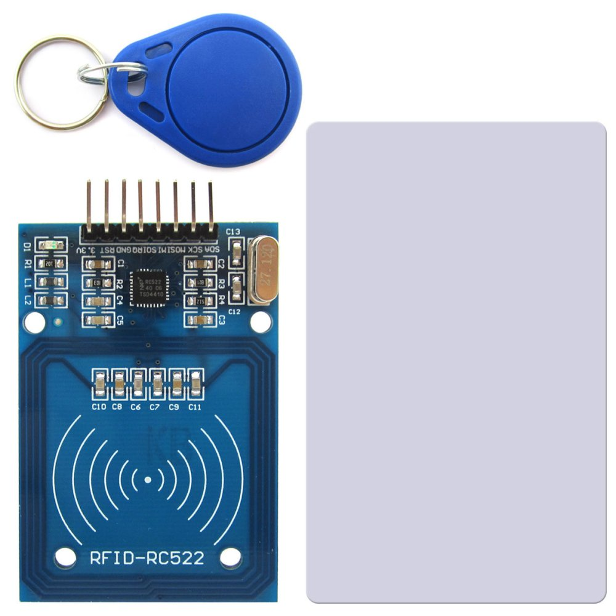

RFID is made up of 3 parts mainly :- They are   
-> RFID tag

-> RFID reader

-> Antenna

**Working Principle:-**

A RFID tag is comprised of a tag chip (sometimes called an integrated circuit or IC) attached to an **antenna** that has been **printed**, **etched**, stamped or vapor-deposited onto a mount which is often a paper substrate or PolyEthylene Therephtalate (PET).

A radio frequency identification **reader (RFID reader)** is a device used to gather information from an **RFID** tag, which is used to track individual objects. Radio waves are used to transfer data from the tag to a **reader.**

**RFID** methods utilize radio waves to accomplish this. **... RFID** tags contain an integrated circuit and an antenna, which are used to transmit data to **the RFID reader** (also called an interrogator). The **reader** then converts the radio waves to a more usable form of data.

This diagram explains the working principle behind the sensor//.

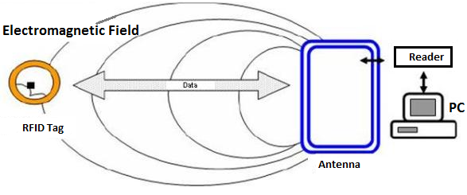

2) ***UltraSonic-Sensor***



  
  
**Working Principle:-** Ultrasonic level sensors work by the "time of flight"

principle using the speed of sound. The sensor emits a

high-frequency pulse, generally in the 20 kHz to 200 kHz

range, and then listens for the echo. The pulse is

transmitted in a cone, usually about 6° at the apex. The

pulse impacts the level surface and is reflected back to

the sensor, now acting as a receiver (as shown in the

above figure ) and then to the transmitter for signal

processing.

Basically, the transmitter divides the time between the pulse and its echo by two, and that is the distance to the surface of the material.

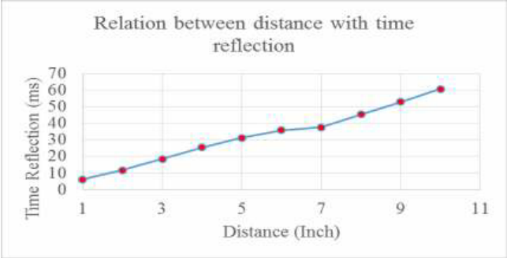

3) ***Buzzer-Sensor***

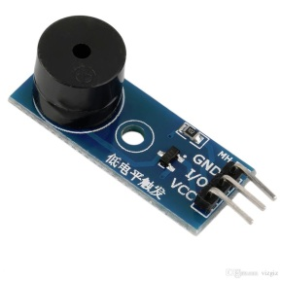

**Working Principle:-**

A **buzzer** or **beeper** is an [audio](https://en.wikipedia.org/wiki/Sound) signalling device,[[1]](https://en.wikipedia.org/wiki/Buzzer#cite_note-1) which may be [mechanical](https://en.wikipedia.org/wiki/Machine), [electromechanical](https://en.wikipedia.org/wiki/Electromechanics), or [piezoelectric](https://en.wikipedia.org/wiki/Piezoelectricity) (*piezo* for short). Typical uses of buzzers and beepers include [alarm devices](https://en.wikipedia.org/wiki/Alarm_devices), [timers](https://en.wikipedia.org/wiki/Timer), and confirmation of user input such as a mouse click or keystroke.

**Piezo buzzer**is an electronic device commonly used to produce sound. Light weight, simple construction and low price make it usable in various applications like car/truck reversing indicator, computers, call bells etc. Piezo buzzer is based on the inverse principle of piezo electricity discovered in 1880 by Jacques and Pierre Curie. It is the phenomena of generating electricity when mechanical pressure is applied to certain materials and the vice versa is also true. Such materials are called piezo electric materials. Piezo electric materials are either naturally available or manmade. Piezoceramic is class of manmade material, which poses piezo electric effect and is widely used to make disc, the heart of piezo buzzer. When subjected to an alternating electric field they stretch or compress, in accordance with the frequency of the signal thereby producing sound

4) ***Smoke(Gas)-Sensor***

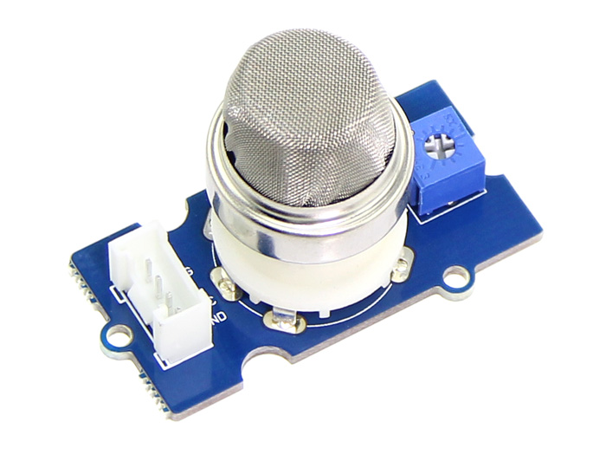

The Grove - Gas Sensor(MQ2) module is useful for gas leakage detection (home and industry). It is suitable for detecting H2, LPG, CH4, CO, Alcohol, Smoke or Propane. Due to its high sensitivity and fast response time, measurement can be taken as soon as possible. The sensitivity of the sensor can be adjusted by potentiometer

There are 4 kinds of gas sensors, every can detect different type of gas. They are :-   
-> MQ2 _______ detects Combustible gas,Smoke

-> MQ3 _______ detects Alcohol Vapor

-> MQ5 _______ detects LPG,Natural gas,Town Gas

-> MQ9 _______ detects CO,coal gas , liquefied gas

**Working Principle:-**

We here take example of Grove-Gas Sensor(O2) and explain its mechanism.

Grove-Gas Sensor (O2) is a kind of sensor to test the oxygen concentration in air, which is based on the principle of the electrochemical cell to the original work. You can know clearly the current oxygen concentration when you output voltage values proportional to the concentration of oxygen and refer to the oxygen concentration linear characteristic graph. It’s very suitable for detecting oxygen concentration in the environment protection. Grove - Gas Sensor(O2) is an organic reaction module, it can provide a little current while putting it in the air, we don’t need to provide an external power to it, and output voltage will change as time current changes.



5) ***AirQuality-Sensor***

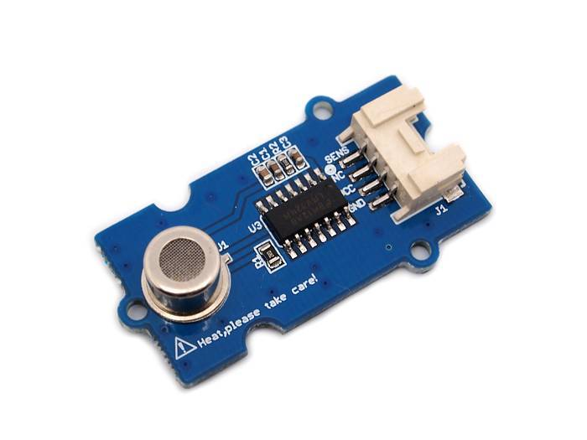

This sensor is designed for comprehensive monitor over indoor air condition. It’s responsive to a wide scope of harmful gases, as carbon monoxide, alcohol, acetone, thinner, formaldehyde and so on. Due to the measuring mechanism, this sensor can’t output specific data to describe target gases’ concentrations quantitatively. But it’s still competent enough to be used in applications that require only qualitative results, like auto refresher sprayers and auto air cycling systems.

Cautions :-

1. Requires relatively clean air as an initial condition.
2. Long time exposure to highly polluted air can significantly weaken its sensitivity.

6) ***DC-Motors***



**Working Principle:-**

***How does it work :-***

DC Motor follows the same principle as that of a DC

Generator. It is a machine that transforms electric energy into

mechanical energy in form of rotation. Its movement is produced by the physical behaviour of electromagnetism. DC motors have inductors inside, which produce the magnetic field used to generate movement.

***How do you Control it :-***

DC motors have only two terminals. If you apply a voltage

to these terminals the motor will run, if you invert the

terminals position the motor will change its direction. If

the motor is running and you suddenly disconnect both

terminals the motor will keep rotating but slowing down

until stopping. Finally if the motor is running and you

suddenly short-circuit both terminals the motor will stop.

***IMPLEMENTATION :-***

Our Smart Office mainly made of three integrated circuits . We will be discussing them one by one.   
  
*1) Entrance and Exit System (SECURITY)*

🡪🡪 ***Requirements***   
 a) RFID Sensor – with card :- 1

b) Arduino :- 1

c) Ultra-Sonic Sensor :- 2

d) DC-Motors :- 2

e) Jumper Wires

🡪🡪 ***Connections and Sensors Data :-***

We would connect the RFID-Sensor ( which is attached to the Main Entrance ) to the arduino and in turn that would be connected to the ultrasonic sensors one in the open area in front of the Second Entrance of the office and the other Ultra-Sonic sensor is placed just in inside at the entrance of the Second Entrance of the Office. This can be seen in the diagrams provided below :-

🡪🡪 ***Idea :-***

When office people want to enter the office they need to swipe their Id card which has a specified RFID-tag given to each person and based on the Information that is obtained from that if that matches. The signal will be given and Main entrance door will be open and while the person/officer moves inside the entrance he ultimately need to pass the open area infront of the Second Entrance in order to get into the office, when he passes that area there is an Ultrasonic sensor attached there which will obtain the data while the person passes the way and based on this information the Door of Main entrance gets closed and the entrance door of the Second Entrance get open. And Finally when the person/Officer enters inside the office there is other Ultrasonic sensor just inside the Second entrance of the office and based on the information it provides as the person passes, the Second Entrance gets closed. This is how the Entrance and Exit System of our Smart Office Works. You can see the implementation in the demo provided below.

**Code:-**





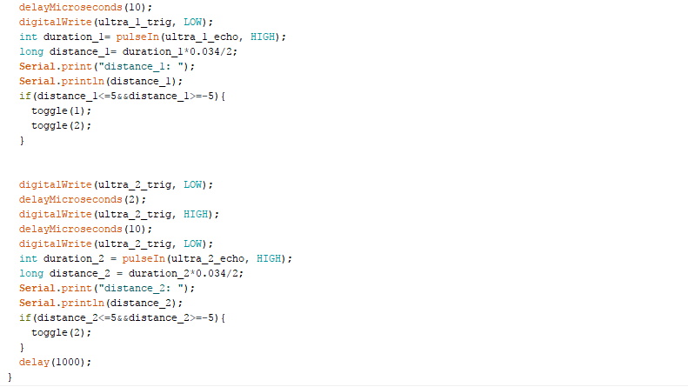

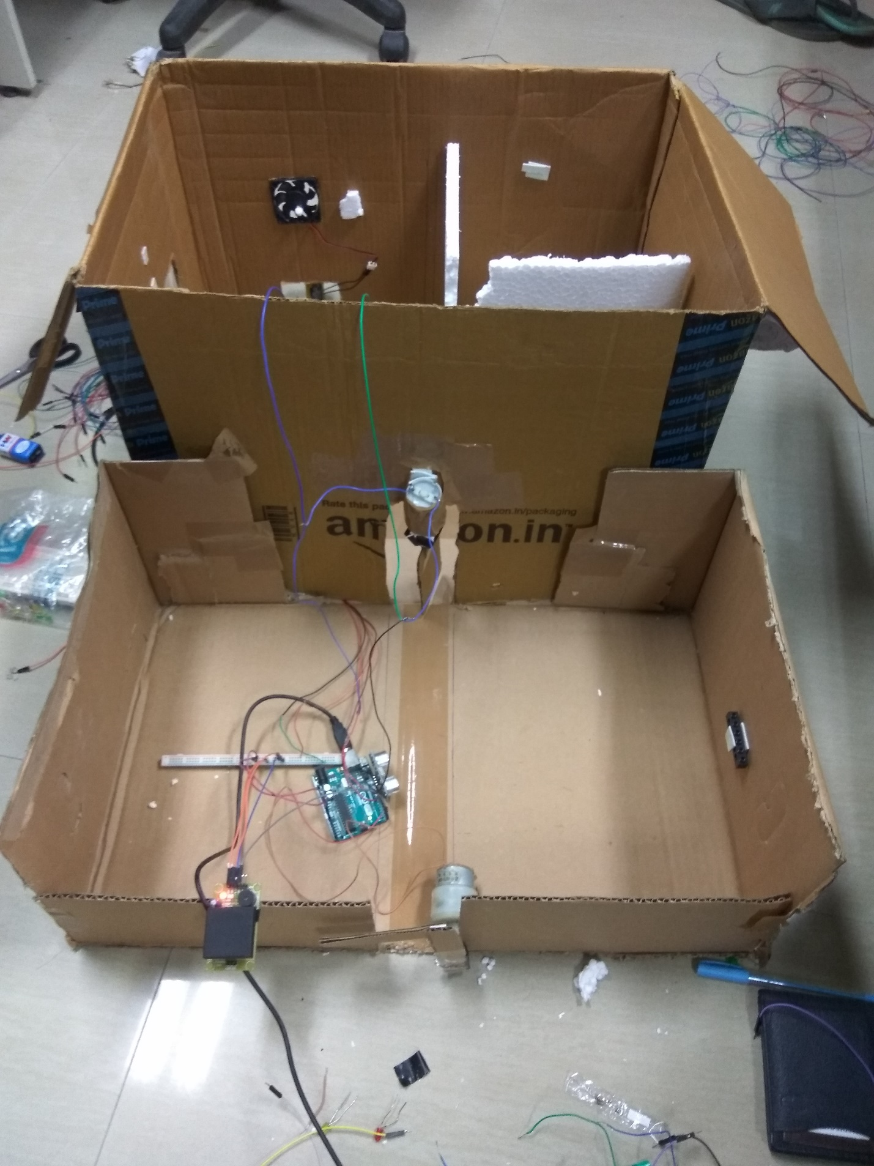

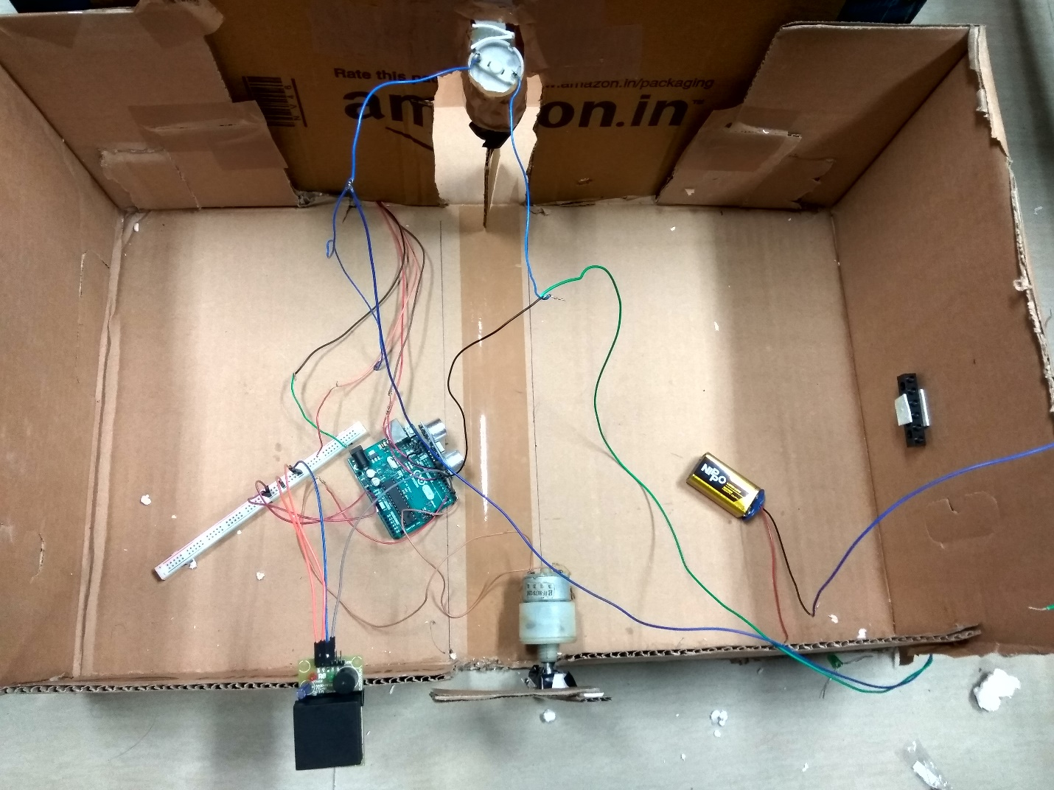

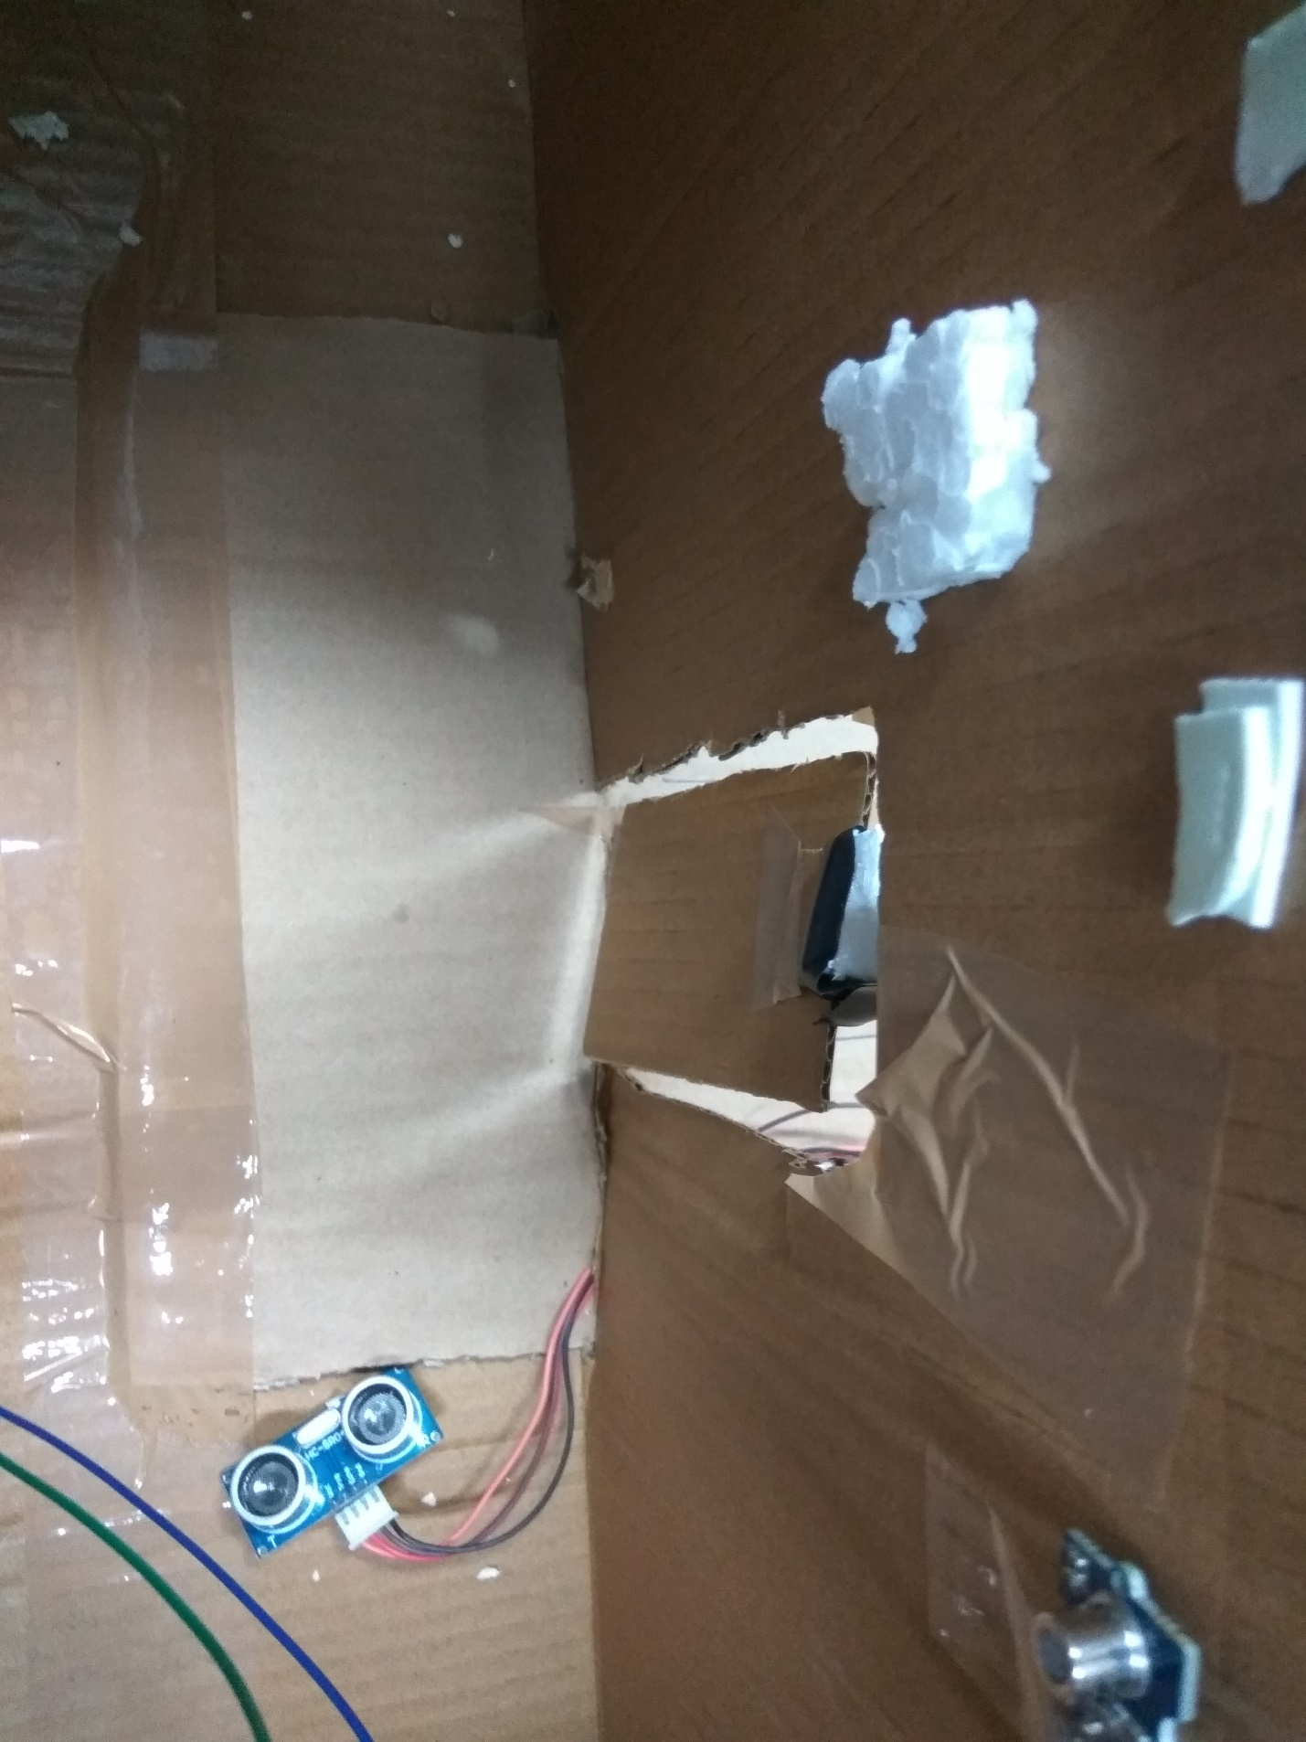

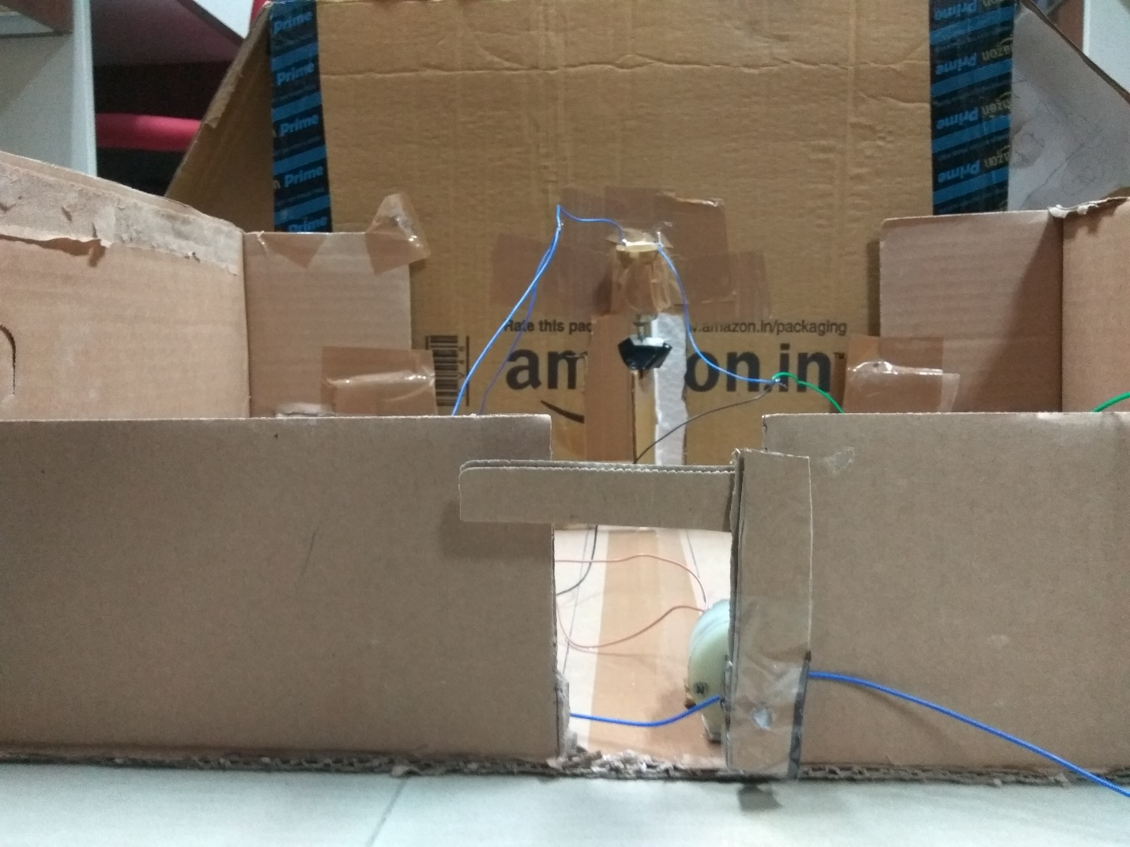

*2) Fire Evacuation (SAFETY)*

🡪🡪 ***Requirements***   
 a) Buzzer Sensor :- 1

b) Arduino :- 1

c) Smoke Sensor :- 1

d) LCD :- 1

e) LED’s :- 4

f) DC-Motors :- 1

g) DC-Fan Set up :- 1

h) Bread-board :- 1

i) Jumper Wires

🡪🡪 ***Connections and Sensors Data :-***

We will connect the LCD- display to the Arduino and the display is placed in the centre of the Office so that all the officers can see the message displayed on the screen. There is a Buzzer Circuit and Smoke sensor that are connected with the Arduino . There is an emergency exit window that will be open using DC-motar based on the information/data we get from the Smoke Sensor. And wiring is done with the help of Bread-board and the LED’s placed on the Bread-board.

🡪🡪 ***Idea :-***

This Integrated Circuit of our Smart Office deals with Evacution /Emergency Fire exit with few more. It has many more involved in it.

** How Buzzer is used :-

$ If Someone in the Office is harassed or in any trouble one can on the Buzzer Circuit so that every officer come to know about that. Once If the Buzzer Circuit is on there will be “Beep” sound and the message “ Something Fishy,Please be Alert” will be displayed on the LCD-display so that everyone in the office come to know about it. In this scenario our smart office gives the Safety to the officers in the office.

** How LCD-Display is used :-

$ In case of normal Situations “Stay Calm and Do work” will be displayed on the LCD-display , in case if the Boss want to send any message to all the offcers like information regarding meetings or anything he can give message and the message gets displayed on the LCD-screen.

** How Smoke sensor,DC-motar is used :-  
 $ In general the Smoke sensor detects the % of CO2 in the atmosphere. If the data obtained from the smoke sensor is more than Threshold value then based on the integration we done the Buzzer Circuit will be on and there will be “Beep” sound and the message “ Fire, Please Evacuate” will be displayed on the LCD-display and the Emergency exit window will be open based on the integration with the DC-motar and the door will be open until the value reduces below the Threshold value. Once if the data collected by the smoke sensor goes below the threshold value the Emergency exit window will be closed the message “Stay Calm and Do Work” will be displayed on the LCD-display and the Buzzer Circuit stops beeping.

** How LED’s are Used :-

$ Other feature is that every officer can control the lights in their Cubicle/in the office.The state of the LED’s get toggle.

** How DC-Fan is used :-

$ And the Boss can control the speed of Fan/AC in his room.

**Code:-**







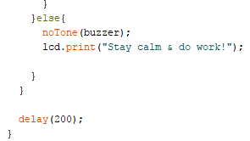

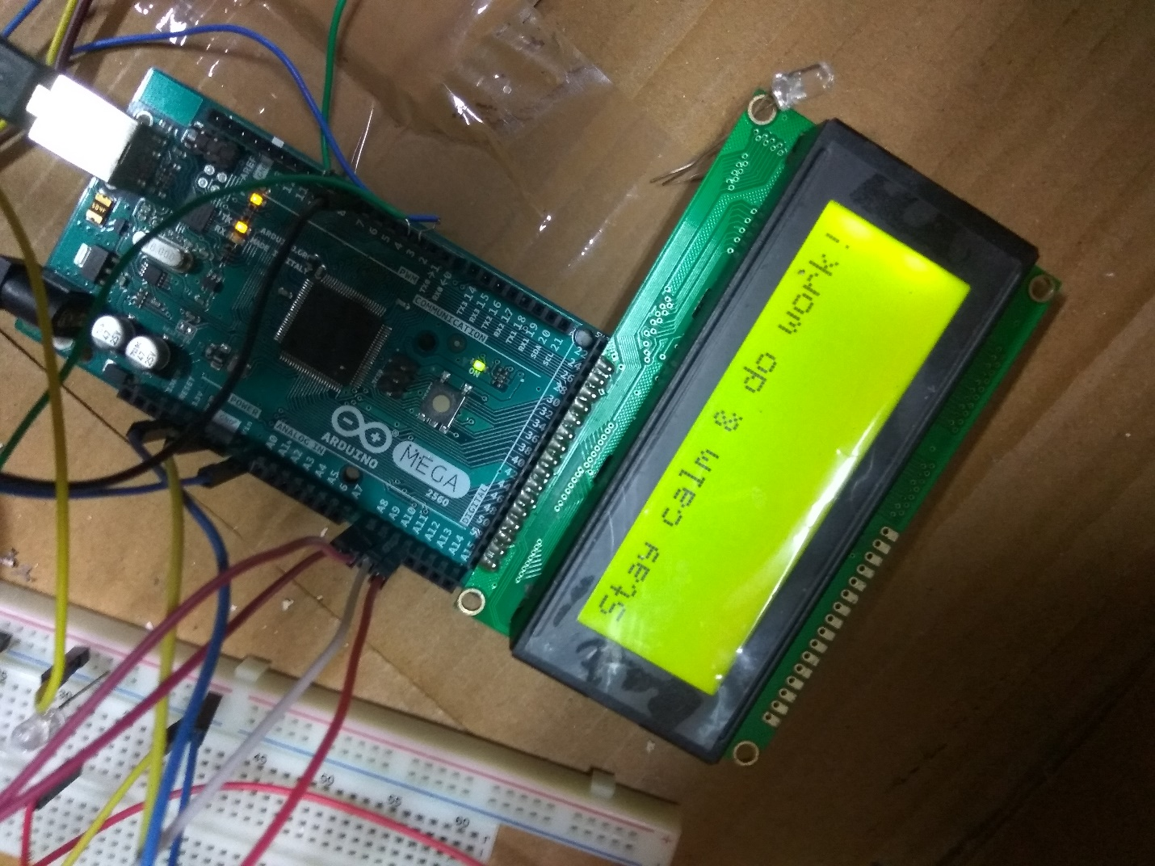

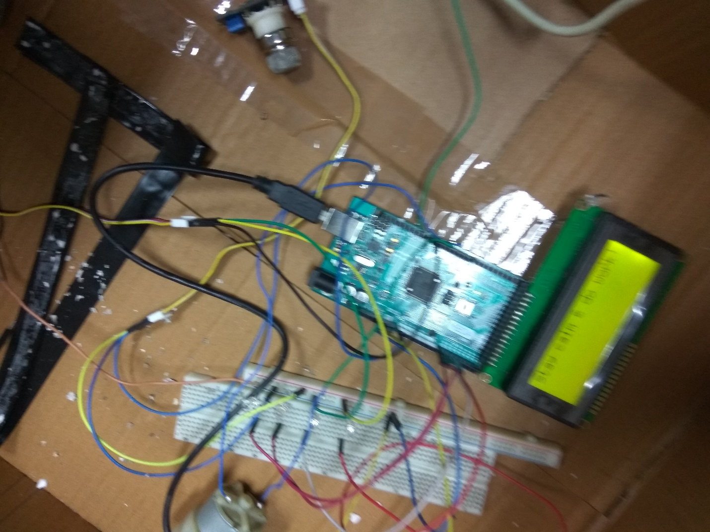

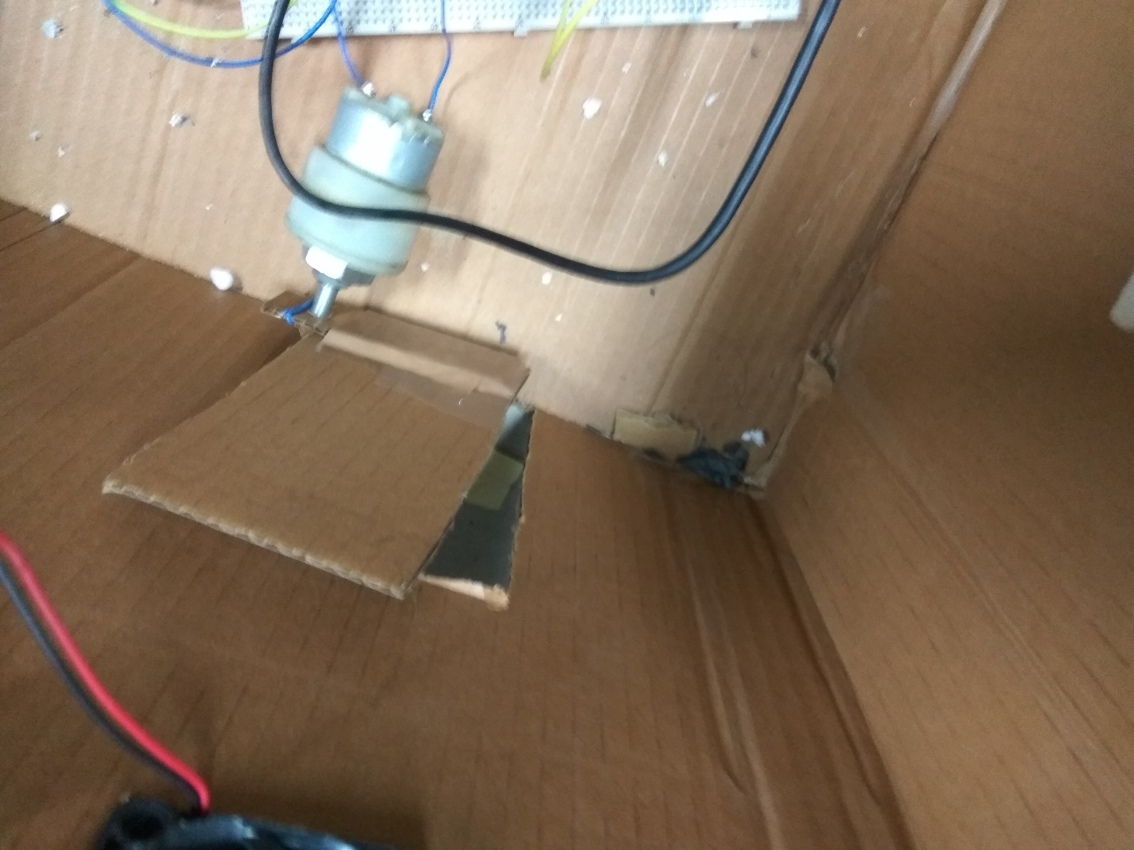

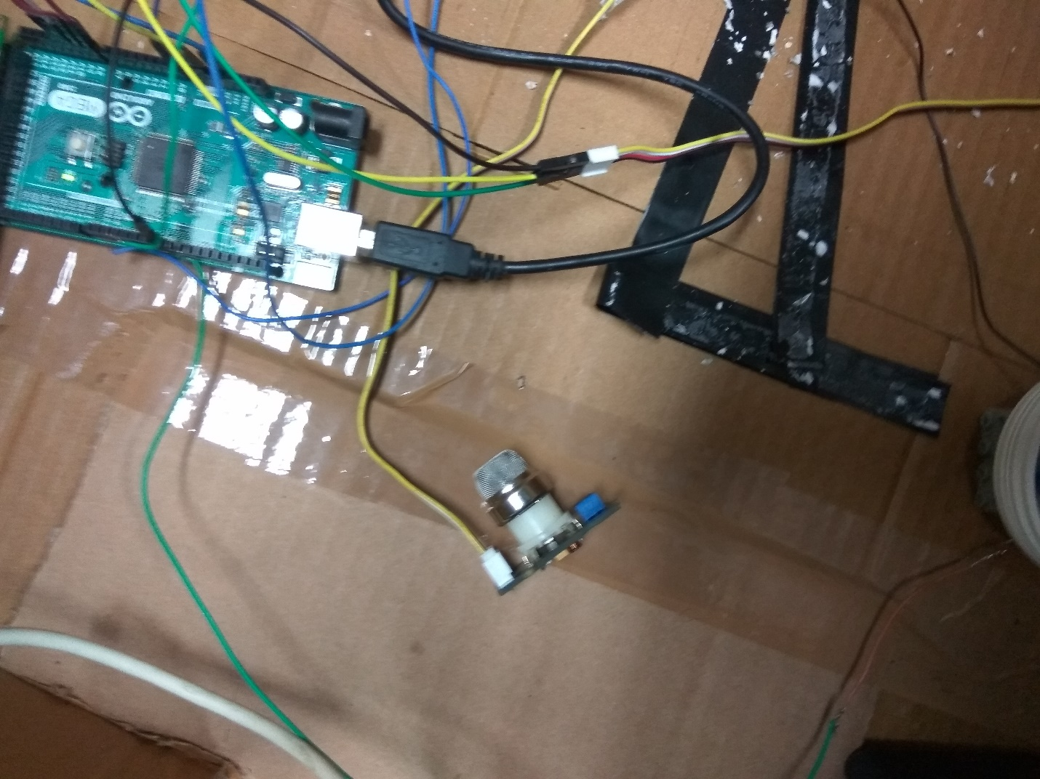

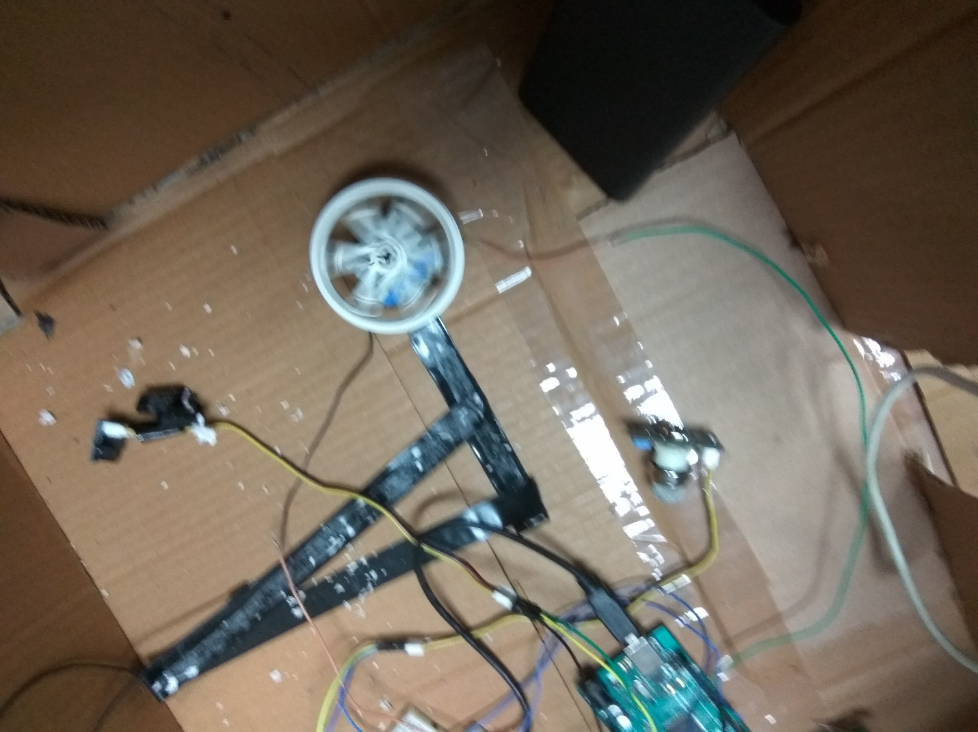

*3) Ventilation System :-*

🡪🡪 ***Requirements***

a) Arduino :- 1

b) Air-Quality Sensor :- 1

c) DC-Fan :- 1

d) Power-Bank :- 1

f) Jumper Wires

🡪🡪 ***Connections and Sensors Data :-***

A DC-Fan is connected to the Arduino and the power to the Arduino is given using Power-Bank. Air Quality sensor is attached to the Arduino

🡪🡪 ***Idea :-***

Based on the readings taken from the Air-Q uality Sensor under normal/fresh conditions the DC-fan which acts like Exhaust fan of the office initially have some speed. Based on the freshness of the air inside the office the Speed of the exhaust fan can be increased in order to let the suffocation inside gets decreased. In this way the Ventilation System of our Smart-Office works.

**Code:-**

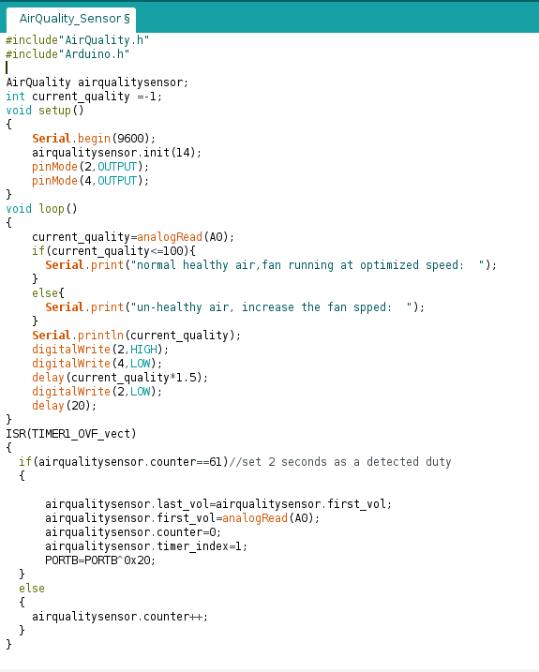

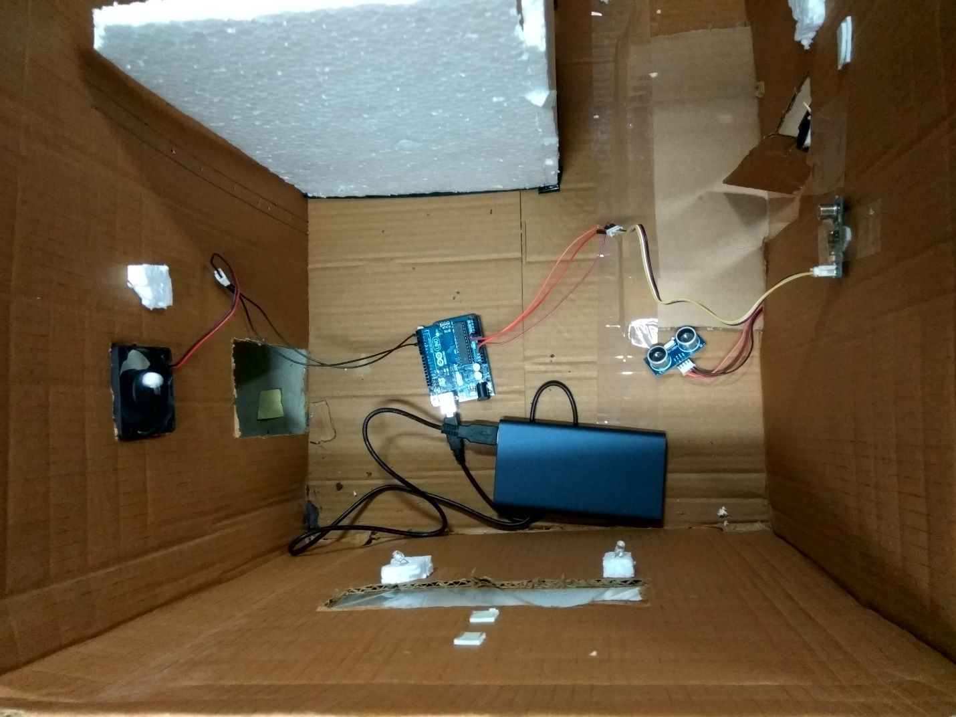

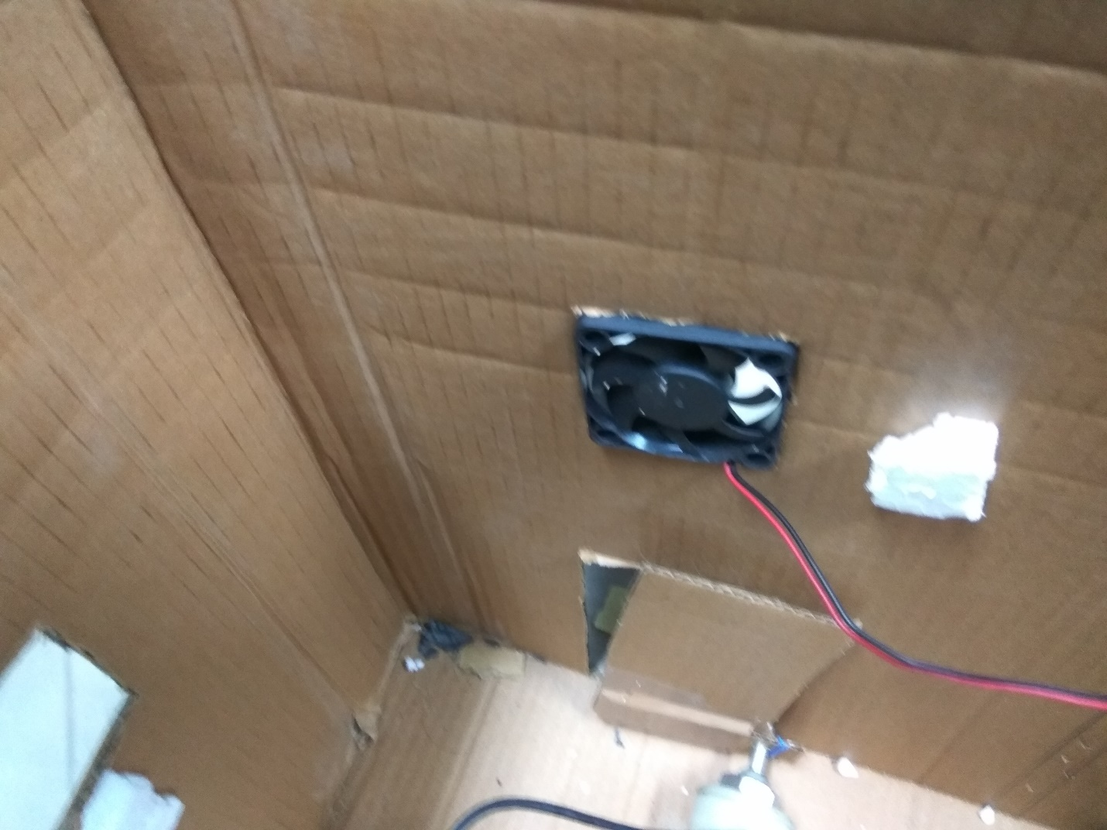

***::MQTT::***

MQTT (Message Queuing Telemetry Transport) is a lightweight messaging [protocol](http://searchnetworking.techtarget.com/definition/protocol) that provides resource-constrained network [clients](http://searchenterprisedesktop.techtarget.com/definition/client) with a simple way to distribute [telemetry](http://whatis.techtarget.com/definition/telemetry)information. The protocol, which uses a publish/subscribe communication pattern, is used for machine-to-machine ([M2M](http://whatis.techtarget.com/definition/machine-to-machine-M2M)) communication and plays an important role in the Internet of Things ([IoT](http://whatis.techtarget.com/definition/Internet-of-Things)).

In this Project we implemented both Wired(Server accessed) and Wireless based MQTT protocol to make our Office still Smart. The features implemented using this protocol are :-

1) If someone in the Office is harassed or in any trouble one can on the Buzzer Circuit so that every officer come to know about that. Once If the Buzzer Circuit is on there will be “Beep” sound and the message “ Something Fishy, Please be Alert” will be displayed on the LCD-display so that everyone in the office come to know about it. In this scenario our smart office gives the Safety to the officers in the office. One can control the Buzzer Circuit from his mobile using MQTT protocol.

2) In case of normal Situations “Stay Calm and Do work” will be displayed on the LCD-display , in case if the Boss want to send any message to all the officers like information regarding meetings or anything he can give message and the message gets displayed on the LCD-screen. Likewise any one can send the message which will be displayed on the Screen from his/her mobile using MQTT protocol.

3) Other feature is that every officer can control the lights in their Cubicle/in the office from their systems/mobiles .The state of the LED’s get toggle.

4) The Boss can control the speed of Fan/AC in his room from his mobile using MQTT protocol.

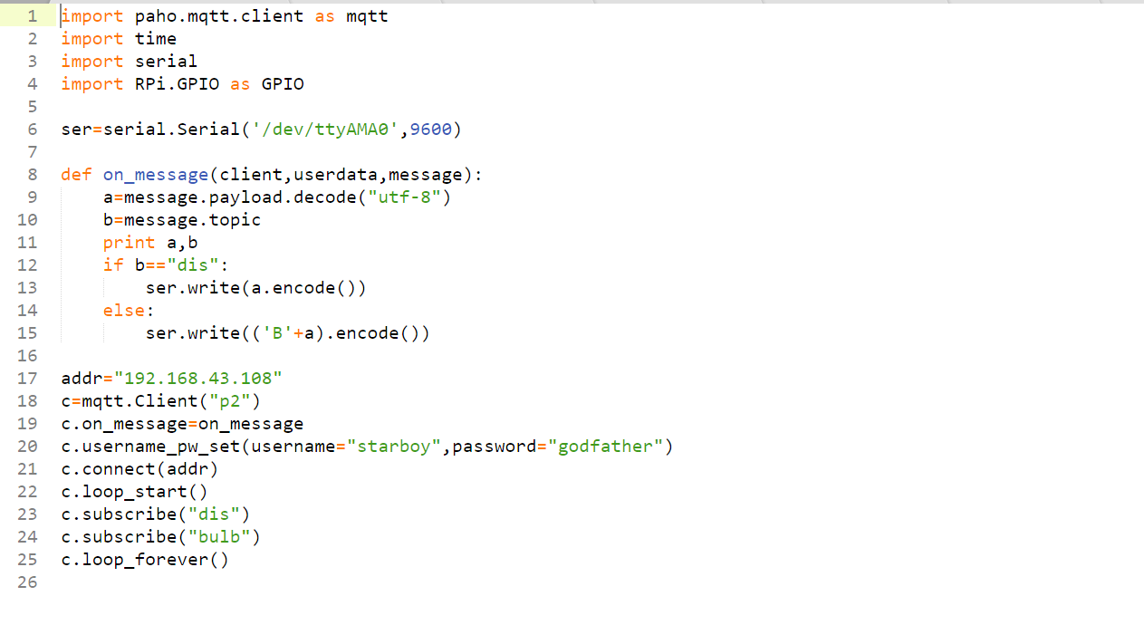

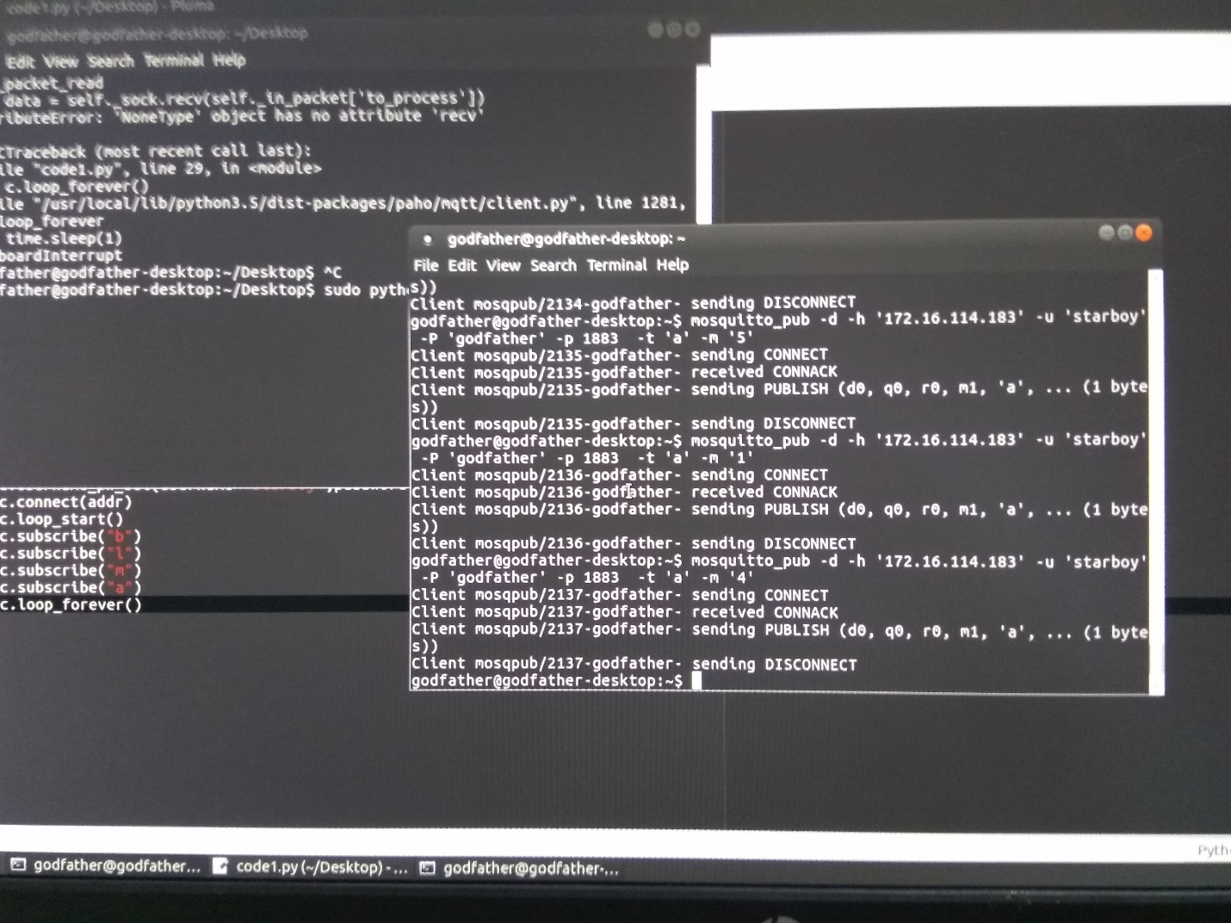

***::Flaws in the System::***

1. In the Entrance and the Exit System , there may be chances that more than one person enters at a time, this is not taken care in our system which requires much more integration between sensors and their data.
2. There are cases when the CO2 levelin the atmosphere increases even the Air-Quality sensor also detects it and increases the speed of exhaust fan but since even this allows the level of CO2 inside to decrease by letting it go outside; so there is no harm involved.

The Google link of the above described Project Video is provided below :-  
 [https://drive.google.com/file/d/1uc9PIDptV1PIVbPH5vAopGfgSGOLdyXj/view](https://l.facebook.com/l.php?u=https%3A%2F%2Fdrive.google.com%2Ffile%2Fd%2F1uc9PIDptV1PIVbPH5vAopGfgSGOLdyXj%2Fview&h=ATPYdzQzHUPnP1HIo3B0XskvXjNU52C2P72k9SqFLHcB4LEL9n3g7b1_00is953iV2PIh_qKXf7Q_dk3b-c_2u68uHxn1o2EGfCQLvXAfnmFKQwmWFPBwQlarpzY8hBfB4lHr1FUnaxH6A)